CS571 Spring 2025 – ICA E
Expert Evaluation
Please make a copy of this document by clicking File > Make a copy. You may share and co-edit it with your fellow group members.

In this in-class activity, you will explore the concept of Expert Evaluation (specifically, a heuristic evaluation) in four steps:

- Prepare for Heuristic Evaluation
- Evaluate and Identify Issues
- Consolidate Identified Issues
- Report Your Evaluation

Areas needing your response are clearly marked with Your Turn! Be sure to complete all aspects of the assignment. Your Canvas submission will be a pdf version of this document.

You may complete this in groups of 1, 2, or 3 people! :) Please be sure to assign yourself and your team member(s) to a group.

1. Prepare for a Heuristic Evaluation
A heuristic evaluation is the one of the expert-review-based methods learned in class. Through this in-class activity, you will practice a heuristic evaluation, particularly using Jakob Nielsen’s usability heuristics. This step prepares you for your evaluation.

Your Turn! Let’s prepare a heuristics evaluation by answering the following questions…

- Remind yourself of the usability heuristics. Ask your team members or the instructor if you have any questions.

There is no deliverable for this step (a).

- What is the website or app that you are reviewing? Please provide a description and representative screenshot of the application.
https://queue.passports.gov.sd/
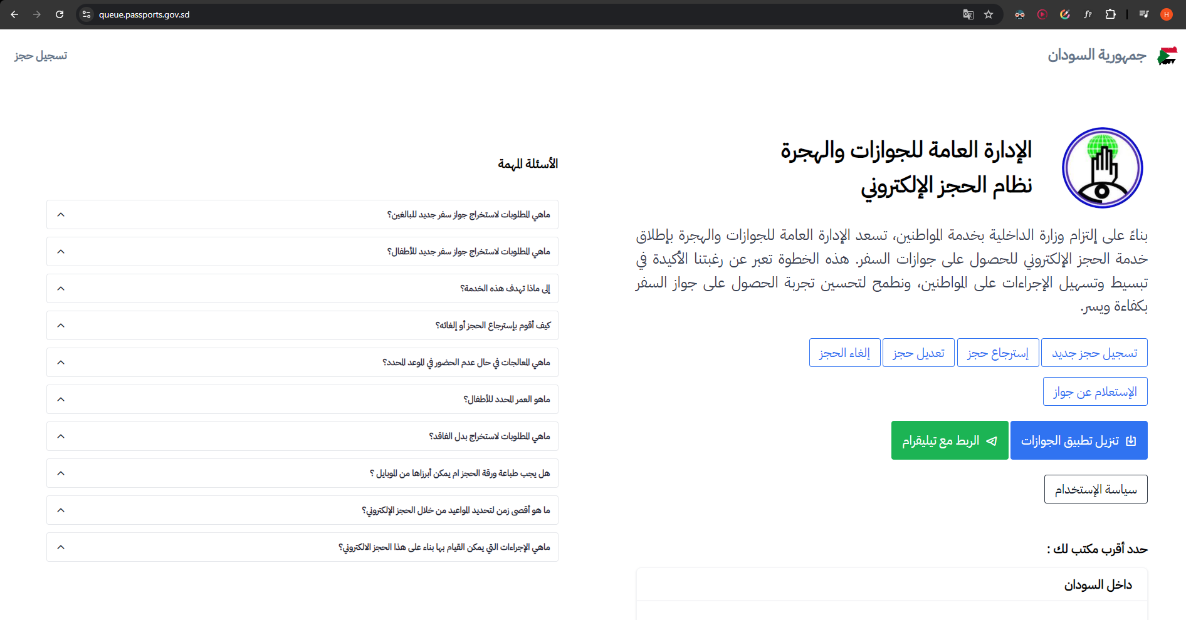
The official Sudanese government website for passport online booking system
- What is the task(s) or area(s) of the website/app that you will be performing your expert evaluation on? It is important that you and your groupmate(s) evaluate the same thing.
The main landing page

2. Evaluate Independently
Now, being familiar with the usability heuristics and having established the grounds for what will be tested, you and your team will perform a heuristic evaluation.

Your Turn! Open the app or webpage that you decided in the previous step. Determine any usability issues using the following table. Not all heuristics may have issues, while other heuristics may have multiple issues. List any issues that you find in its appropriate cell, as well as recommendations for addressing that issue.

Remember, this step must be conducted independently! Make copies of the table below for each of your group member(s) and include them in this document.

Heuristics | Issues | Recommendations
- Visibility of System Status
- Match Between System and the Real World | They don’t provide alternative language other than Arabic | Add an option to change the language
- User Control and Freedom | The logo clicking doesn’t return you back to the main page, you have to do it manually through the back arrow | Make the logo clicking action take the user back to the main page
- Consistency and Standards | Color palette and fonts are not harmonized | Unify the design components
- Error Prevention
- Recognition Rather Than Recall
- Flexibility and Efficiency of Use
- Aesthetic and Minimalist Design | Alot of details in a single page | Break the information inputting to multiple stages
- Help Users Recognize, Diagnose, and Recover from Errors
- Help and Documentation

3. Consolidate Identified Issues
It is time for collaboration! There are no right/wrong answers here; share your evaluation and thoughts with your teammate and discuss!

Your Turn! Share your evaluation results with your groupmate(s) (i.e., what issues you identified during the evaluation), and then discuss. If you are working alone, you may answer the questions below independently!

- Complete the table below. What are the top 3-5 usability issues that you have collectively decided as a team? What heuristic does it violate? For each of these issues, what are your recommendation(s) for addressing them?
Issue | Heuristic Violated | Recommendation

- Collectively decide on the top 1 usability issue found in this evaluation. List the issue, the heuristic that it violates, and your recommendation for resolution. You will generate a report for this in the next step.

4. Report Your Evaluation!

Finally, you should report your evaluation! You will highlight the worst usability problem and suggest a solution.

Your turn! Complete your evaluation by answering the following questions…

- Provide a screenshot of the screen or page to show the location of the worst usability problem; annotate what the problem is and where it resides.
- What is your recommendation for resolution of this issue? You may expand on your answer from 3(b) to discuss trade-offs or other alternative suggestions.
- Using your recommendation from above, show what an improved version of this interface would look via a sketch or mockup. You may take a screenshot and sketch over the existing application, or sketch from scratch.

After completing this document, please be sure to upload it as a PDF in Canvas!

